Graph Calculator 1.1 Manual

Contents

1) Introductions 1

2) GC Appearance 1

3) Draw a Function 4

a) Simple Function 6

b) Implicit Function 6

c) Constant Function 7

d) System of Inequalities 8

4) Changing Function Properties 10

5) More Configuration 12

6) Delete a Function 15

7) Clear All Functions 16

8) Several Notes 17

9) Closing 18

# Introductions

Hi! In this manual, I’m going to show you how to draw a graph of a function using Graph Calculator (GC). I will always try to update this manual if there are any new changes.

Before I advance any further, let me tell you first that this version is different from the previous version. “What are the differences?”. Well, of course this version is more powerful than the previous version. Not only that, but the appearance and how to operate it are also different. So, if you want to use the previous version, you must read the Graph Calculator Manual (without 1.1). But I suggest you use this version instead because it’s more powerful!

To make it simpler, when I said “draw a function”, that will mean “draw a graph of a function”. At least it will save my time. So, let’s get started!

# GC Appearance

First thing first, let me show you the new appearance of GC 1.1. After you open Graph Calculator 1.1.exe, this window will appear.

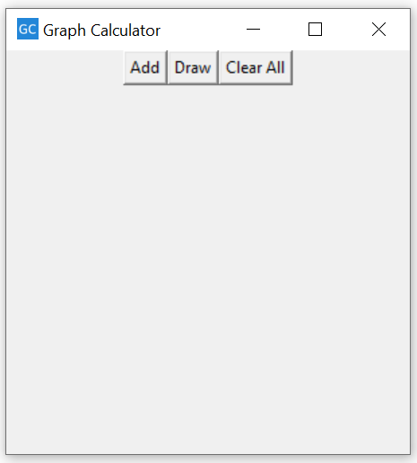

“What?! There are only three buttons. How can I draw the function?”. Well, when you click “Add” button, it will become like this.

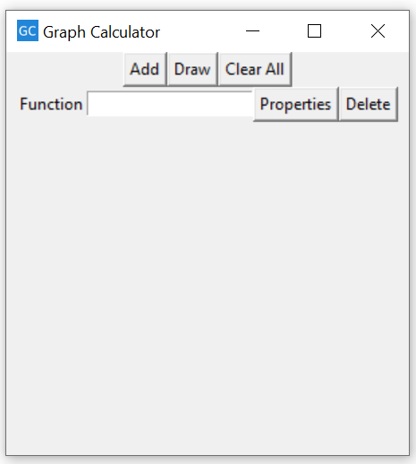

Now, I’ll tell you what are those.

|  |  |  |
| --- | --- | --- |
| Icon | Name | Functions |
|  | Add Button | Add new function. |
|  | Draw Button | Draw all functions. |
|  | Clear All Button | Delete all functions. |
|  | Function Box | Input the function. |
|  | Properties | Properties of the function. |
|  | Delete | Delete current function. |

If you press the **Properties Button**, a new window will appear.

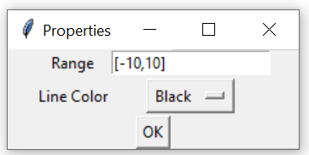

Let me tell you what are those.

|  |  |  |
| --- | --- | --- |
| Icon | Name | Functions |
|  | Range Box | Specify the domain. |
|  | Line Color Options | Specify curve’s color. |
|  | OK Button | Save all properties. |

After you input a function or several functions, and press **Draw Button**, a new window will appear.

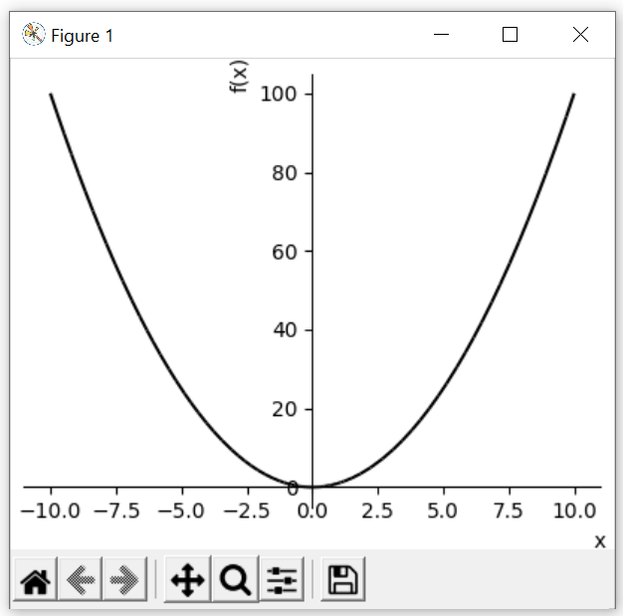

Wow cool! Now let me tell you what those buttons below are.

|  |  |  |
| --- | --- | --- |
| Icon | Name | Functions |
|  | Reset Button | Reset the view to the original view. |
|  | Backward Button | Back to previous view. |
|  | Forward Button | Forward to next view. |
|  | Move Button | Move the view, zoom $x/y$ fixed axes. |
|  | Zoom Button | Zoom to rectangle. |
|  | Configuration Button | Configure the plot. |
| **7** | Save Button | Save the figure. |

# Draw a Function

Alright, now is the main course. “How can I draw a function using GC?”. Let me tell you first the basic idea of drawing a function using GC 1.1.

1. Every time you want to input a function, click the **Add Button**. This button is used to add a new function to be drawn. I’ve shown you above that after you click **Add Button**, the **Function Box**, **Properties Button**, and **Delete Button** will appear. If you want to input another function, just click **Add Button** again. You can draw as many functions as you want in one figure!

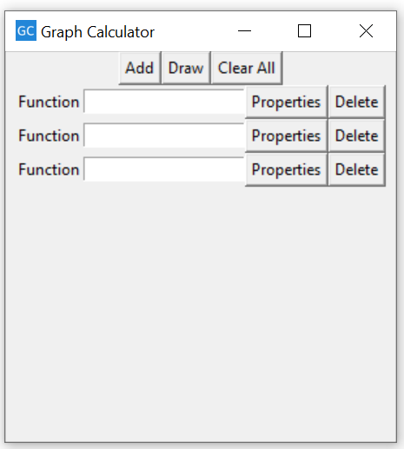

1. Then, just input the function you want to draw in the **Function Box**.

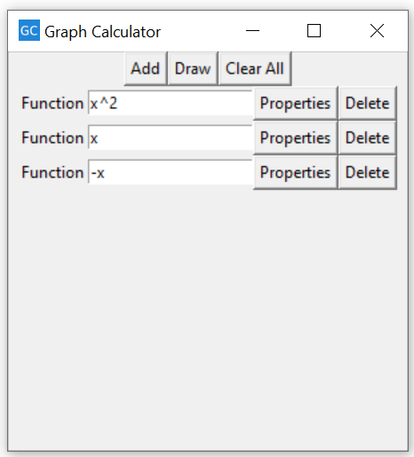

1. If you have finished inputting the functions, just click the **Draw Button** to draw those functions.



Voila! Your functions have been drawn in the new window.

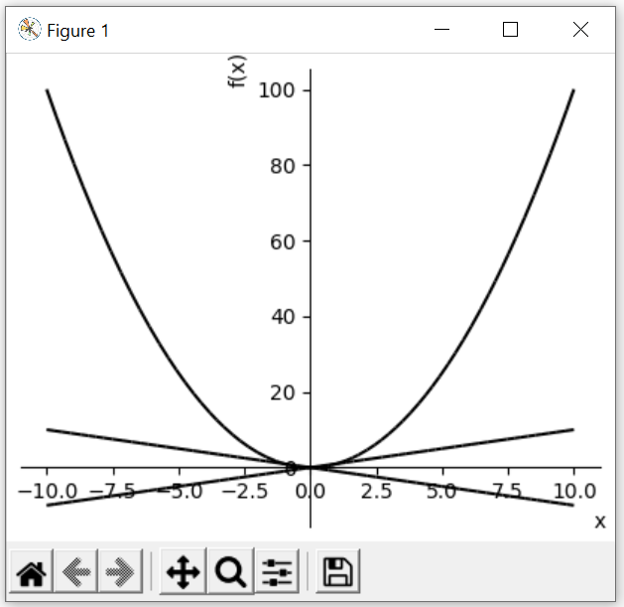

That’s all the basic idea on how to draw a function. Whatever the function you want to draw, the steps are always the same. The differences are just the way you input the equation.

## Simple Function

What I mean with “simple function” is an explicit one variable function. For example: $x^{2}, x+2,\sin{x}$, etc. You can draw polynomial functions (linear, quadratic, cubic, etc.), trigonometry functions (sin, cos, tan, sec, csc, cot), exponents and logarithm functions, radical functions (only square root is available), and rational function (only available for defined domain). Always remember that the function you inputted is ***the function of $x$*** . So, you can’t input $t^{2}$ or $sin⁡(θ)$, etc. The example is on the above.

## Implicit Function

“What if I want to draw a circle, or a function that I can’t express explicitly?”. Don’t worry, you can draw an implicit function. But you must write the equation ***only one of the sides***. For example: if you want to draw a circle $x^{2}+y^{2}=4$, then you must change it first to be equal to zero like this $x^{2}+y^{2}-4=0.$ After that, you will only write the left side ($x^{2}+y^{2}-4$) in the **Function Box**. Look at the figures below!

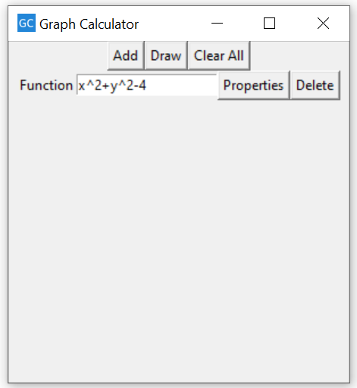

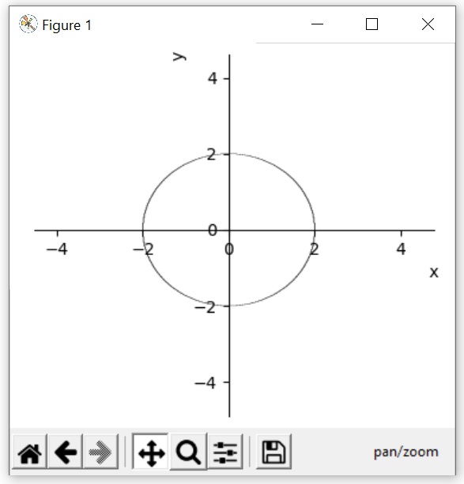

At first, it will look like an oval. But don’t worry, you can rescale the figure (see Section 5)).

## Constant Function

“What if I want to draw a constant function? Is it the same as draw implicit function?”. Well, yes. But you need to add a “special code” in front of the equation. For example: if you want to draw a line $x=2$, then you must change it first to be equal to zero like this $x-2=0.$ After that, you will only write the left side ($x-2$) in the **Function Box**, ***and add “c: ” in front of the equation*** like this $c:x-2$. Look at the figures below!

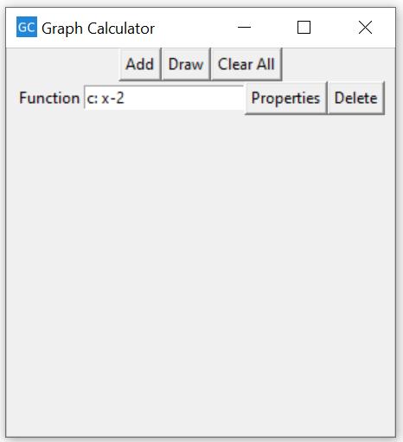

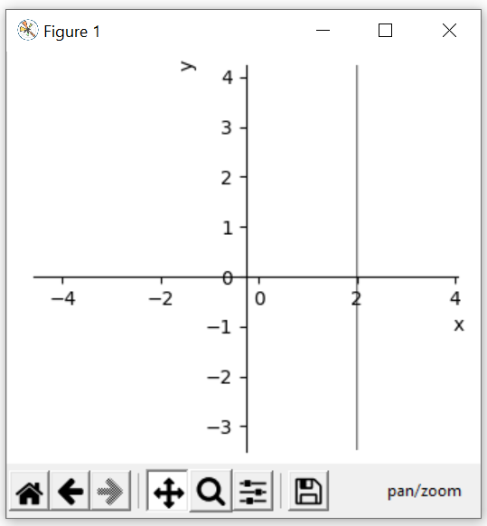

“Why should I add that special code?”. Well, it will tell the calculator that you want to draw a constant function $x=2$. If you just write $x-2$ without giving the special code, then the calculator will interpret it as a simple function $y=x-2$. Do you get it now? 😊

## System of Inequalities

GC can draw inequality? Of course, it can! But the way to do it is not quite intuitive. You must write the inequalities in **j*ust one Function Box*.** You must also add a new “special code”. For example, you want to draw system of inequalities $x+y≤2, 2x+3y≤6, x≤0, y≤0$. This time, you ***don’t need to change it into one side equation*.** Just write it as it is. But ***you must add “And(” in front of your system of inequalities, and add the closing parentheses “)” in the end***. Look the figures below!

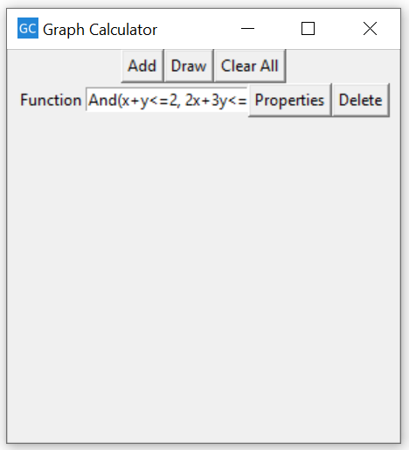

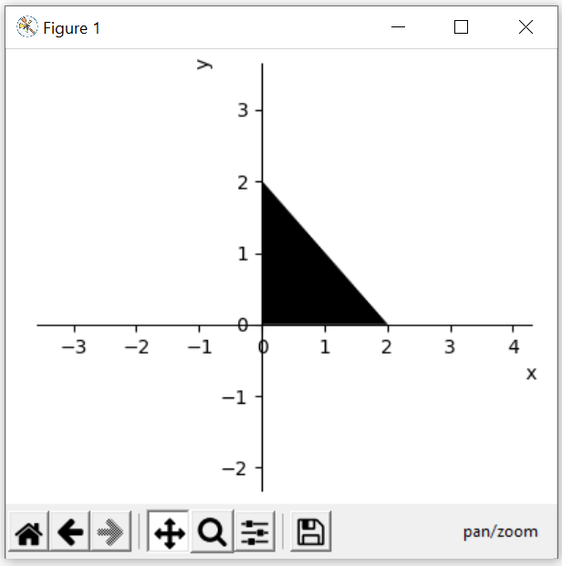

Note: Sorry I can’t show the equation until the end. But trust me, I used the closing paratheses!

“What is that?! That’s just a dark triangle!”. Well, yes, you’re right. It just draws the feasible region. If you want to add the lines, just add new functions, and draw the implicit function. Look at the figures below!

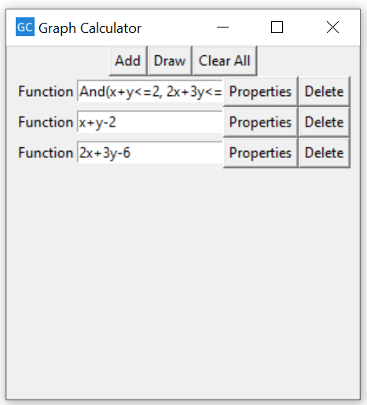

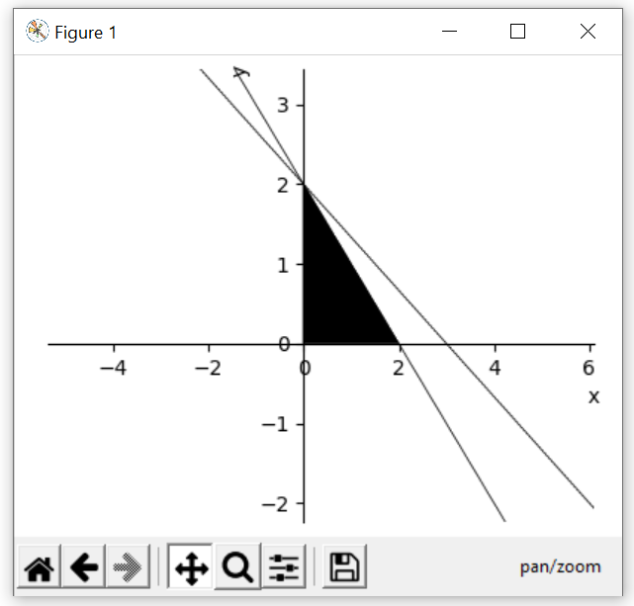

Voila! Here is the graph you want! 😊

“Why again should I add the special code?”. Well, because you want to get the feasible region of the system of inequalities, not just the solution of each of the inequalities. For example: using the example of system of inequalities before, if you input each of the inequalities on different function box, then the calculator will think that you want to draw the solution of $x+y≤2$ OR $2x+3y≤6$ OR $x≥0$ OR $y≥0$. In other words, your figure will entirely black! That’s why it will be error even if you input a single inequality without adding the special code.

# Changing Function Properties

“What if I want to specify the domain? What if I want to change the curve’s color?”. Don’t worry, you can change it in **Properties**.

1. After you add a new function, click the **Properties Button**.



1. Just like I’ve shown you far above, the Properties window will appear. Input the domain you want the graph to show in **Range Box**. The default range is $[-10,10]$. If you want to change the range, ***don’t forget to use bracket ([ ])***.

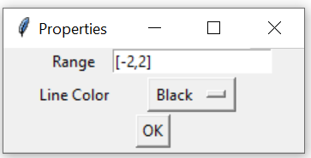

1. If you want to change the line’s color, just click the **Line Color Options** (the one with the ‘Black…’ word). You will be then given several available colors. Just click whatever color you want. The default color is Black.

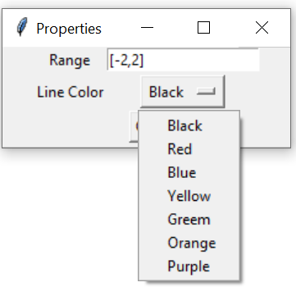

1. Then, click **OK** to save all of the properties.



# More Configuration

Maybe sometimes you don’t like the view of your graph. You can move the view or zoom a specific area. You can also save your figure! I will show you how to do that.

1. If you want to change the view of you graph, you can press the **Move Button**. Then left click and drag the figure anywhere you want. You will understand more if you also try it.

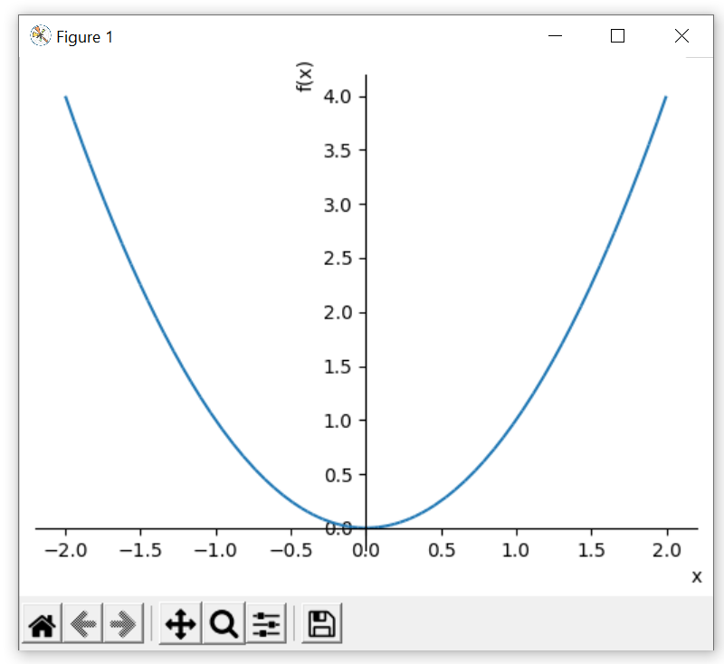

1. If you want to zoom the area you want or rescale the figure, there are two methods to do so. You can choose either of those.

* First method is by pressing the **Move Button**, then right click and drag the figure.



* Second method is by pressing the **Zoom Button**. Then, you must create a rectangle shape to zoom the area inside the rectangle. Just right click and drag to create the rectangle.
* 

1. If you want to reset the view to its original view, just press the **Reset Button**.



1. If you want to go back to last previous view/last next view, just press **Backward/Forward Button**.



1. More configuration can be found in **Configure Button**. Try to explore it yourself!



1. If you want to save your figure, just press the **Save Button**.



Don’t be confused with the file extension names! Here are three common file extensions used to save an image:

* Portable Network Graphics (PNG).
* Joint Photographic Expert Group (JPEG).
* Portable Document Format (PDF).

# Delete a Function

If you have already inputted a function but you want to delete it/not include it in the new figure, just click the **Delete Button**.



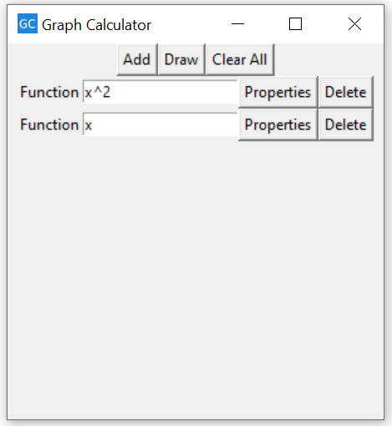

# Clear All Functions

If you want to delete all functions, you can do the exact thing as in Section 6) for each function. But if you’re lazy enough to do that, just click the **Clear All Button**.





# Several Notes

Since this app is still under development and is still far from perfect, there are several things you must consider. I’ve mentioned it before in above, but I will tell it again.

Don’t worry with the black window that appear every time you open GC. That’s just the “python effect”. It will show the error if you make a mistake. If you’re familiar with python, then you will understand the error.

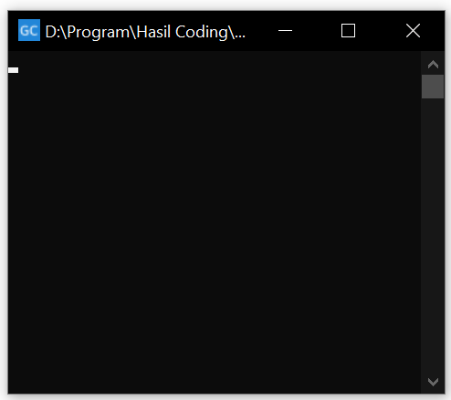

This version is now smart enough to detect the multiplication operation. So, if you write 2x(x^2+3x-4), it will read it as 2*x*(x^2+3*x-4). But when you want to include special function/symbol (such as sin, cos, tan, log, exp, pi, sqrt), you must still use the multiplication sign. For example: if you want to write $xe^{x}$, $2\sin{x}\cos{x}$, then you must write it as x*exp(x), 2*sin(x)*cos(x).

The only available letters you can use to be the variables are “ $x$” and “ $y$”. You can’t use any letters/Greek alphabet other than those.

Don’t worry if you don’t change the properties. The default domain for $x$ will be $[-10,10]$ and the default curve’s color is black.

# Closing

Well, I think I’ve covered all of what GC 1.1 is capable of. I’ll be sure to update the manual if there Is any new changes. Please feel free to comment or give any suggestion on what feature should be added in the future. Happy drawing 😊